
Name: TEACHER:

YEAR 11 SEMESTER TWO 2004

HUMAN BIOLOGY EXAMINATION

TIME ALLOWED:

Reading Time before commencing: 10minutes
Working Time for paper: 3 hours

MATERIAL REQUIRED/RECOMMENDED FOR THIS PAPER:

TO BE PROVIDED BY THE SUPERVISOR:
Question/Answer Booklet
Multiple Choice Answer Sheet
Lined paper

TO BE PROVIDED BY THE CANDIDATE:
Standard Items: pens, pencils, eraser, ruler.
Special Items: 2B, B or HB pencil for the separate Multiple Choice Answer Sheet
Calculators satisfying conditions set by the Curriculum Council.

STRUCTURE OF THIS PAPER
PART | No of Questions available | No of Questions to be attempted | Marks | Your score
1 Multiple choice | 40 | ALL | 80 | /40
II Short Answer Questions |  | ALL | 80 | /40
Extended Answer Questions | 4 | 2 | 40 | /20

IMPORTANT NOTES TO CANDIDATES:
No other items may be taken into the examination room. It is your responsibility to ensure that you do not have any unauthorised notes or other items of a non-personal nature in the examination room. If you have any unauthorised material with you, please hand it to the Supervisor BEFORE reading any further.
PART ONE: 40 MULTIPLE CHOICE QUESTIONS.
Mark your answers to questions 1-40 on the separate multiple choice answer sheet, using a 2B, B or HB pencil. If you make an error rub out the incorrect choice and put a cross over the correct answer. Also place the new letter choice next to the question number so there is no confusion.

- Amino Acids resulting from the digestive breakdown of protein are mainly absorbed in the:
  - Stomach
  - Pancreas
  - Small intestine
  - Large intestine

- Which of the following statements about the development of the fertilised ovum is INCORRECT?
  - Fertilisation produces a zygote which contains 46 chromosomes.
  - The fertilised ovum undergoes several mitotic divisions.
  - The morula develops a cavity and becomes a blastocyst.
  - The blastocyst implants in the endometrium 3 weeks after fertilisation.

- The first sign of syphilis is usually:
  - A small copper coloured rash at the site of contact.
  - Benign growths occurring randomly in the body.
  - White ulcers in the mouth.
  - Superficial sores at the site of contact.

- Which of the following statements about pregnancy is INCORRECT?
  - During late pregnancy women urinate more often because the expanding uterus exerts pressure on the bladder.
  - The lungs of the foetus are collapsed until birth.
  - The chorion is made from the mother’s cells.
  - The umbilical vein carries oxygenated blood from the placenta to the foetus.

- Which of the following groups of nutrients are absolutely essential for human survival?
  - Fats, proteins and vitamins.
  - Carbohydrates, vitamins and minerals.
  - Vitamins, minerals and proteins.
  - Carbohydrates, fats and proteins.

- Which is NOT a function of saliva:
  - Lubricates the mouth.
  - Contains antibodies that kill bacteria.
  - Dissolves food so the taste receptors can be stimulated.
  - Mechanical digestion.

Refer to the graph below to obtain information for questions 7 and 8.
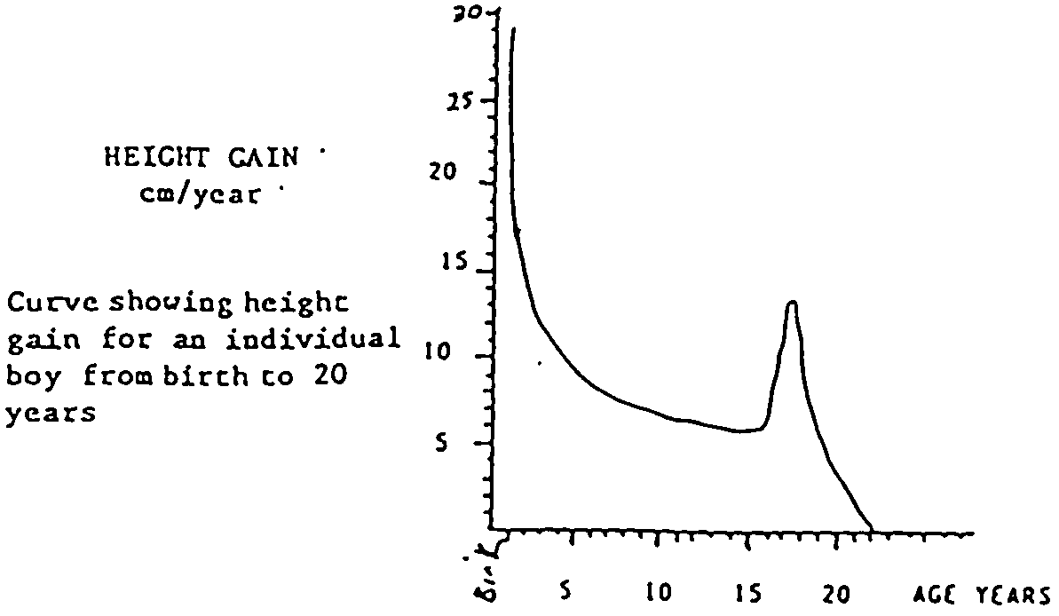

- The boy’s maximum growth rate occurred during:
  - 0 – 2 years
  - 4 – 6 years
  - 10 – 12 years
  - 14 – 16 years

- A similar graph drawn of the height gain of a particular girl between the ages of 8 and 20 years would be:
  - To the right of the present graph line.
  - To the left of the present graph line.
  - The same as the present graph line.
  - Impossible to state with certainty.

- The foetus is most susceptible to viral infections and drugs which would cause malformations during the:
  - First 3 months of pregnancy.
  - Period between months 3 – 9 of pregnancy.
  - Period between months 3 – 6 of pregnancy.
  - Period between months 6 – 9 of pregnancy.

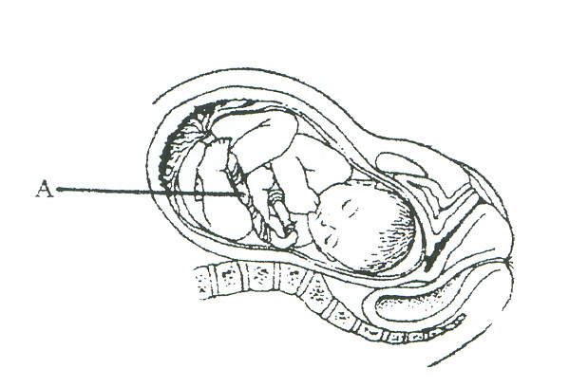
- In the diagram above the structure labelled A is the:
- Placenta.
- Chorion.
- Amniotic sac.
- Umbilical cord.

- Cardiovascular disease is presently the most serious health problem in Australian society. The commonest cause of this disease is hypertension (high blood pressure). Which of the following suggestions is recommended to prevent hypertension?
  - Moderately smoking, drinking and eating anything.
  - Regular exercise and a careful dietary program.
  - Limiting energy and salt intake, regular daily exercise, relaxation sessions and no smoking.
  - None of the above.

Questions 12 and 13 refer to the following diagram.

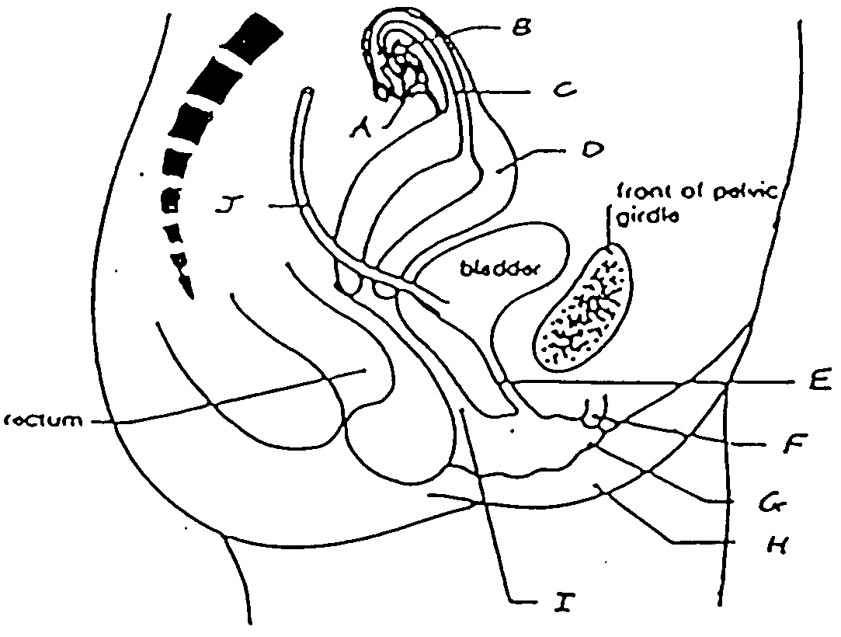

- Structures D, E and I are respectively identified as:
  - Vagina, clitoris, labia.
  - Uterus, ureter, urethra.
  - Vagina, fallopian tube, uterus.
  - Uterus, urethra, vagina.

- Structure C is:
  - The site of gamete combination.
  - Receives sperm of the male.
  - The site of embryo development.
  - Eliminates urine from the body.

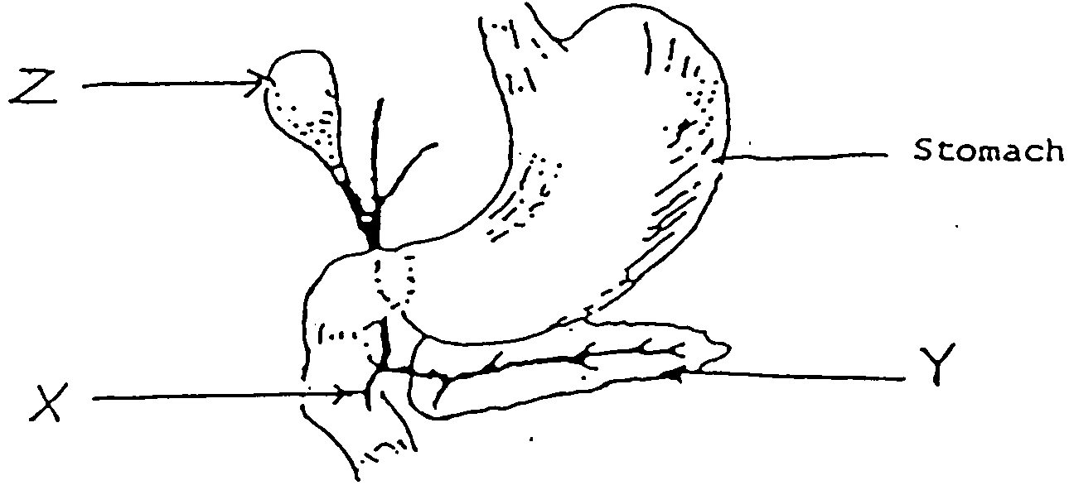

- In the above diagram, which of the following pairs of substances pass through structure X?
  - Pancreatic juice and bile.
  - Bile and chyme.
  - Amylase and mucous.
  - Bile and hydrochloric acid.

- Which of the following are necessary for protein synthesis?
  - Amino acids, DNA, ADP and phosphate.
  - Amino acids, ATP, phosphate and energy.
  - Amino acids, DNA, enzyme and energy.
  - Amino acids, ADP, enzyme and phosphate.

- Spermatogenesis and oogenesis are processes occurring in male and female reproductive organs respectively. They are necessary processes because:
  - They produce enzymes for reproductive functions.
  - Without these processes humans would not survive.
  - They are vital in producing haploid cells.
  - They are vital in producing diploid cells.

- The corpus luteum is responsible for the secretion of:
  - Cortisone.
  - Oestrogen.
  - Luteinising hormone.
  - Progesterone and oestrogen.

- Which of the terms below refer to observable physical differences between males and females?
  - Primary sex characteristics.
  - Tertiary sex characteristics.
  - Dimorphism.
  - Secondary sex characteristics.

- Which of the following is a method that cannot lead to the spread of HIV?
  - Having unprotected sex.
  - Blood transfusions in countries where blood is not tested.
  - Toilet seats in public toilets.
  - Sharing needles and syringes.

Graph showing growth rates of human organ systems

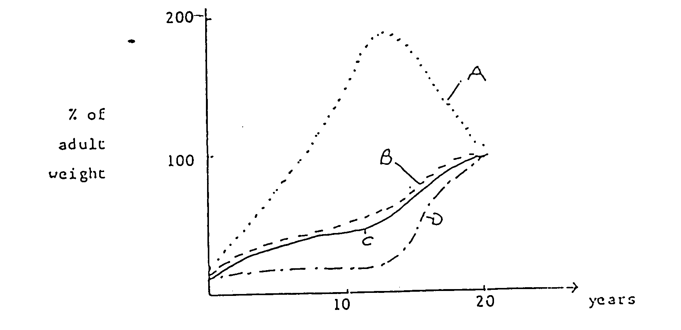

- In the graph above, line A and D represent respectively, growth of:
  - The reproductive and nervous systems.
  - The immune and nervous systems.
  - Cartilage in the skeleton and total body weight.
  - The immune and reproductive systems.
QUESTION 21 AND 22 REFER TO THE FOLLOWING INFORMATION:
The graphs show some of the changes that occur in females during the menstrual cycle.
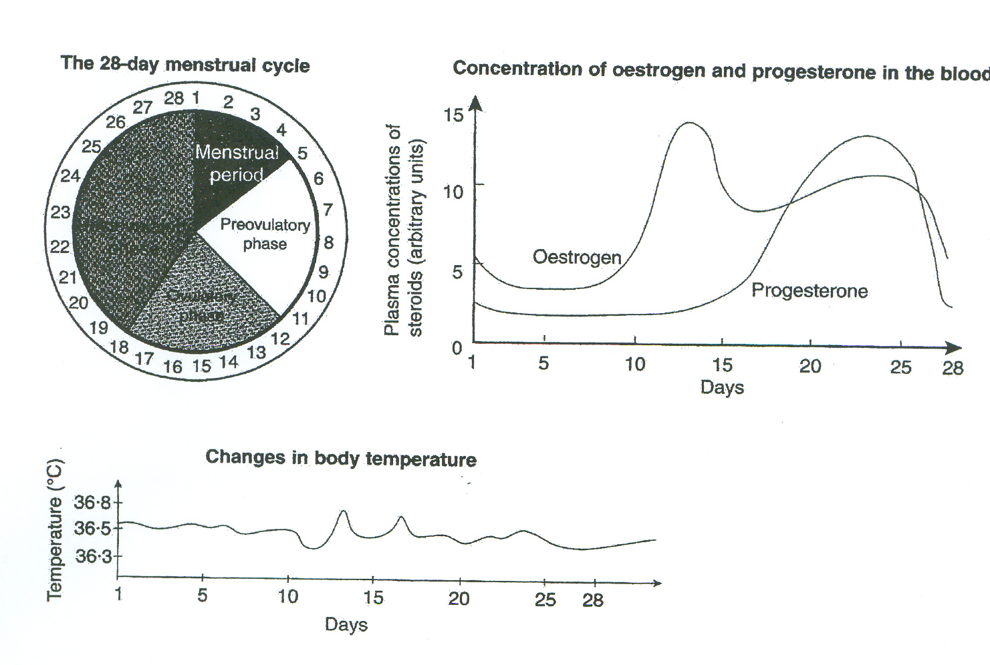

- During which phase of the cycle does the maximum body temperature occur?
  - Menstrual.
  - Pre-ovulatory phase.
  - Ovulatory phase.
  - Post-ovulatory phase.

- Levels of progesterone in the blood are at a maximum around which day of the cycle?
  - 5th day.
  - 12th day.
  - 20th day.
  - 23rd day.

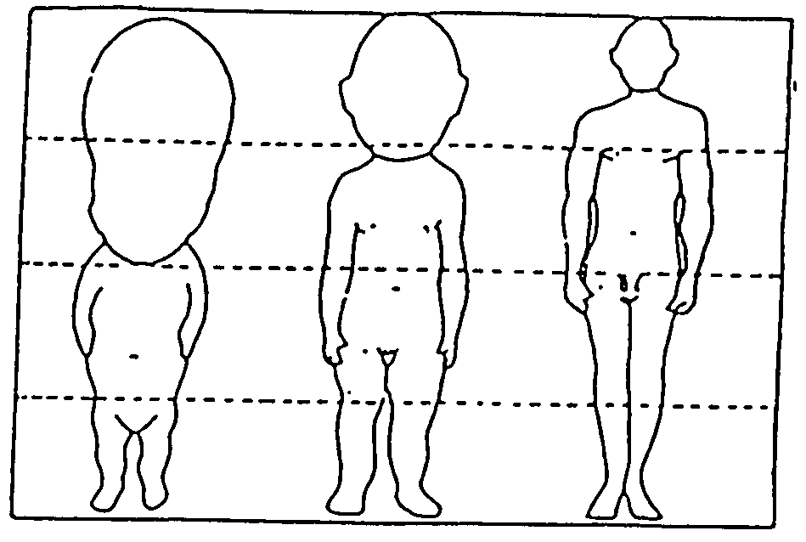

- The above diagram shows 3 stages in human development. The proportions have been made equal. Which of the following statements is INCORRECT?
  - The length of the legs increases in proportion to the body parts.
  - The parts of the body develop at different rates.
  - The head is decreasing in size.
  - The arms increase in proportion to the body.

- In mammals, most enzymes cease to function when the pass from one part of the alimentary tract to another. Which one of the following statements is the most likely explanation for the generalisation?
  - Different substrates require a variety of enzymes.
  - Enzymes are affected by temperature changes.
  - Some enzymes will only operate in a relatively narrow pH range.
  - Absorption of the products of digestion has occurred and enzyme reaction is no longer necessary.

- Which of the following best describes osmosis?
  - The movement of molecules from an area of higher concentration to one of lower concentration.
  - The ability of a membrane to regulate the molecules passing through it.
  - The movement of water through a differentially semi-permeable membrane.
  - The process of transporting molecules against a concentration gradient.

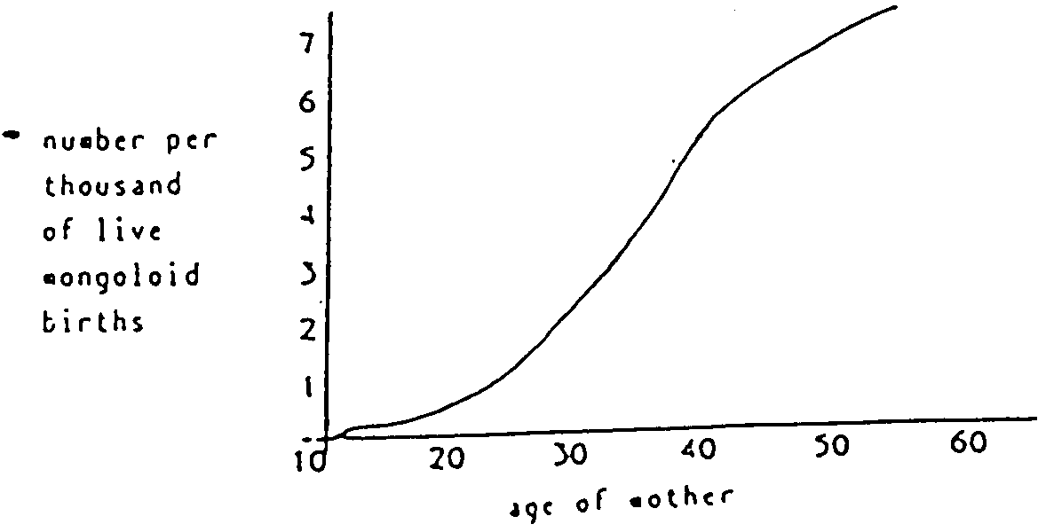

Number per thousand of live mongoloid births

Age of mother

- From the information contained in the graph above, which of the following conclusions is INCORRECT?
  - Young women (less then 25) are unlikely to give birth to a mongoloid baby.
  - The frequency of Mongoloid births increases as the mother’s age increases.
  - Women at age 40 years of age have a 1 in 200 chance of having a Mongoloid child.
  - Live Mongoloid births do not occur across the range of mother’s ages.

- The milk secreting regions of the human breast are called:
  - Lobes.
  - Lobules.
  - Alveoli.
  - Areola.

- Which of the following contains a body part that’s not involved in digestion?

  - Stomach, Liver and gall bladder.
  - Gall bladder, Liver and colon
  - Stomach, duodenum and Liver
  - Stomach, trachea and Liver

- A patient was diagnosed with the following symptoms: soft bones especially the legs which continued to bow when walking. This person would most likely be suffering from?
  - Spina bifida.
  - Rickets.
  - Scurvy.
  - Lack of iron in diet.

- Rapid, repeating uterine contractions responsible for the dilation of the cervix prior to birth are better known as:
  - Labour pains.
  - Peristalsis.
  - Braxton hicks pains.
  - All of the above.

- Which of the following best describes the second stage of the dying process?
  - Body temperature falls and disintegration occurs.
  - Muscles contract and the heart stops beating.
  - The pupils dilate and the person urinates.
  - The brain loses consciousness.

- The term ‘coitus interruptus’ refers to which of the following statements?
  - The application if a chemical that kills the male sperm after ejaculation.
  - The sudden feeling of well being that accompanies ejaculation.
  - The withdrawal of the penis before ejaculation.
  - The movement of the egg from the fallopian tubes into the uterus.

- Which of the following is not a sign of aging at a cellular level?
  - There is a reduced ability to metabolise fats.
  - Cellular respiration is increased as some cells get older.
  - There is an increase in the number of breaks in the DNA molecule.
  - The mitochondria tend to become swollen.

- By which method are the genetic disorders Down Syndrome and Muscular Dystrophy detected?
  - X-ray.
  - Fetoscopy.
  - Amniocentesis.
  - Oogenesis.

- The development into sexual maturity is termed:
  - Adolescence.
  - Puberty.
  - Growing pains.
  - Maturity.

- A guide to whether an individual is overweight is calculated using the body mass index. This is calculated in the following way:

BMI = Weight (Kg)
Height x Height (m)
To interpret the results a standardised chart has been constructed.

CONDITION | BMI
Underweight | 19.9 or less
Acceptable weight | 20-25
Overweight | 25.1-30
Obese | 30.1-40
Extreme obesity | 40.1 or more

If a 1.57 m woman weighed 63kg, into which category would she fall?
  - Underweight.
  - Overweight.
  - Acceptable weight.
  - Obese.

- The main function of the large intestine is:
  - Absorption of bile.
  - Absorption of fatty acids and glycerol.
  - Absorption of water.
  - Absorption of blood.

- During the 16th century, many people led a seafaring life. Many of these sailors had dietary deficiencies and were diagnosed with scurvy. Which of the following vitamins is responsible for this condition?
  - Vitamin C
  - Vitamin E
  - Vitamin D
  - Vitamin K

- Cephalocaudal patterns of motor development means that development occurs:
  - From head to foot.
  - From close to the body to the extremities.
  - From large muscles to small.
  - From head to hands.

- Digested lipids would be in the form of:
  - Amino acids and glucose.
  - Glucose and glycerol.
  - Fatty acids and sucrose.
  - Fatty acids and gycerol

END OF PART ONE

Name: TEACHER:

YEAR 11 SEMESTER TWO 2004

HUMAN BIOLOGY EXAMINATION

PART 2: SHORT ANSWER SECTION.

- Fill in all answers in this booklet.
- Spelling and grammar will count towards your mark.
- This section is worth 40 %
- Good luck.

PART 2: SHORT ANSWERS QUESTIONS
Answer all of the questions in the spaces provided.
41 a. Write the correct word for the following definitions in the following table.
    - The membrane forming a cavity around the embryo;
secretes a fluid into the cavity to protect the embryo.
    - The tube that carries the sperm away from the testes.
    - The process in which the cervix widens to allow birth.
    - The tooth type most responsible for crushing and grinding food.
    - The period of pregnancy.

a.
b.
c.
d.
e.
(5 marks)

41 b. Name the structure illustrated and describe how the structure aids in the function of the cell.
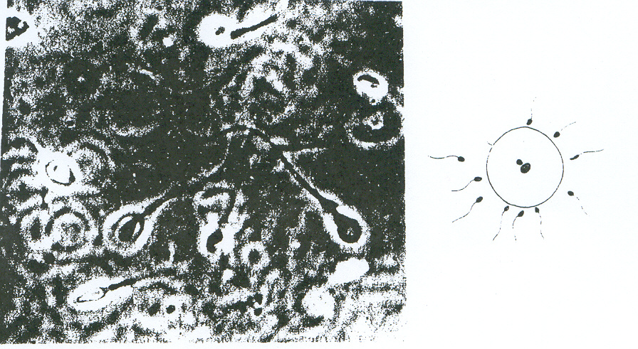
___________________________________________________________
___________________________________________________________
___________________________________________________________
___________________________________________________________
___________________________________________________________
(1 mark)
41 c. Vasectomy is an operation used to sterilize men. Explain what structures are operated on and how the technique prevents conception.

___________________________________________________________
___________________________________________________________
___________________________________________________________
___________________________________________________________
___________________________________________________________
___________________________________________________________
(2 marks)
41d. Why is castration an unsuitable procedure for male sterilization.
___________________________________________________________
___________________________________________________________
(1 mark)

42 a. Use the diagram below to identify structures A – H.
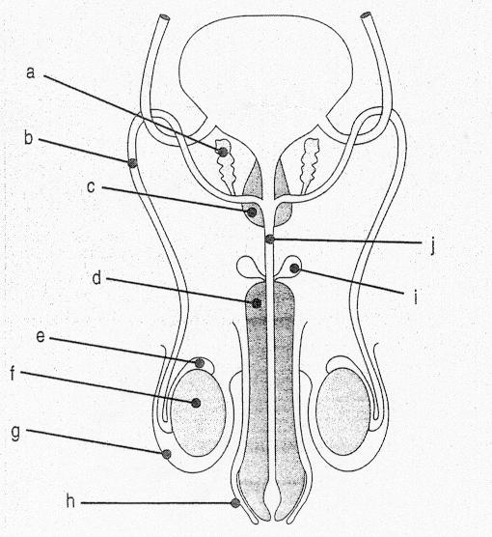

A _________________________ E _________________________
B _________________________ F _________________________
C _________________________ G _________________________
D _________________________ H _________________________
(4 marks)
42 b. What is the function of structure G?
___________________________________________________________
___________________________________________________________
___________________________________________________________
(1 mark)
42 c. Describe two main functions of semen?
___________________________________________________________
___________________________________________________________
___________________________________________________________
(1 mark)
42 d. Describe how structure D allows the process of erection to occur.
___________________________________________________________
___________________________________________________________
___________________________________________________________
(1 mark)

43 . Number of notified cases of Gonorrhoea and Syphilis in Western Australia for the years 1985-96.

YEAR | GONORRHOEA | SYPHILIS
1985 | 1700 | 380
1986 | 1580 | 290
1987 | 1080 | 300
1988 | 1030 | 250
1989 | 750 | 260
1990 | 730 | 200
1991 | 720 | 285
1992 | 850 | 350
1993 | 830 | 170
1994 | 850 | 120
1995 | 860 | 100
1996 | 870 | 90

a) Plot the results on a line graph. (4 marks)

b) Give an explanation for a drop in both diseases in the early 1990’s.
___________________________________________________________
___________________________________________________________
___________________________________________________________
(1 mark)
c) Complete the table.
 | GONORRHOEA | AIDS
CAUSE
SYMPTOMS
TREATMENT
(5 marks)

44 a. Label the structures A – D from the diagram below.
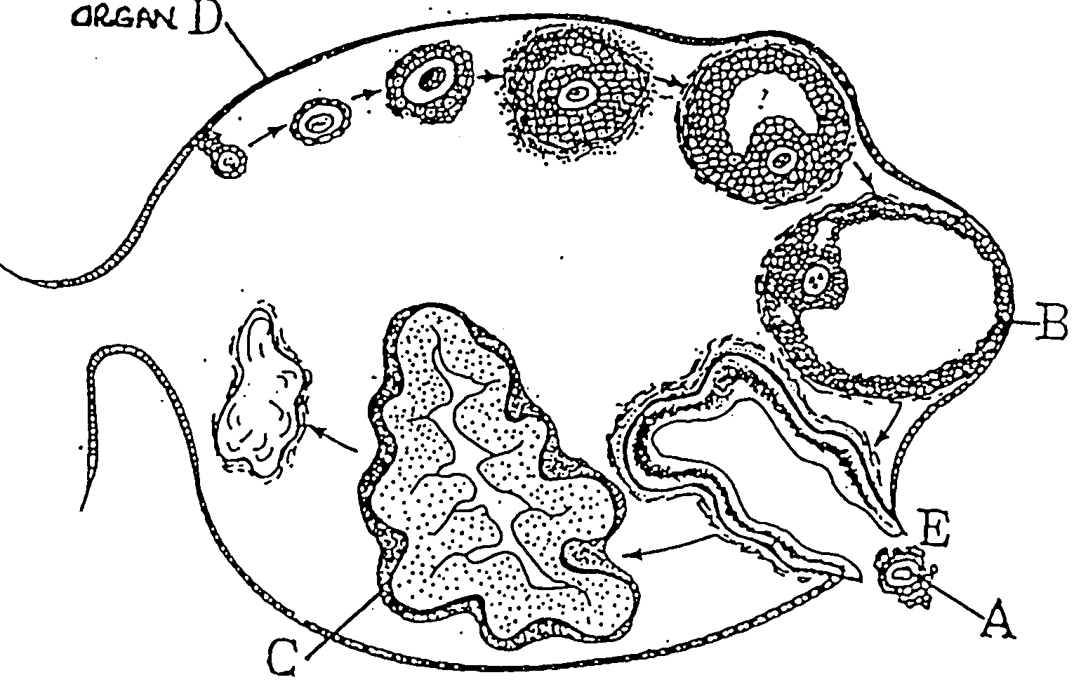

A ________________________________________
B ________________________________________
C ________________________________________
D ________________________________________
(2 marks)
44 b. Structure B develops under the influence of a hormone.
(i) Name this hormone ______________________________________________
(ii) From where is it secreted? ________________________________________
(1 mark)
44 c. Structure C secretes a hormone.
(i) Name this hormone ______________________________________________
(ii) Name one effect of this hormone ___________________________________
(1 mark)

44 d. What does stage E represent?
___________________________________________________________
(1 mark)

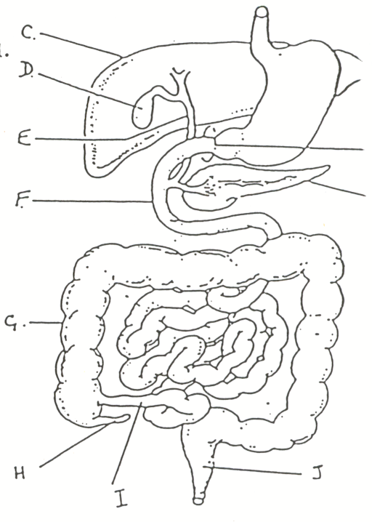
45 a. Study the diagram of the digestive system below and provide labels for the structures listed.
A
BG

A ____________________________
B ____________________________
C ____________________________
D ____________________________
E ____________________________
F ____________________________
G ____________________________
H ____________________________
I ____________________________
J ____________________________
(5 marks)
45 b. Give the functions of structures D and I.
D ___________________________________________________________

I ___________________________________________________________
(1 mark)
45 c. Explain why little or no carbohydrate digestion occurs in the stomach.
___________________________________________________________
___________________________________________________________
___________________________________________________________
(1 mark)
45 d. Explain the role of the pancreas in lipid digestion.
___________________________________________________________
___________________________________________________________
___________________________________________________________
___________________________________________________________
(2 marks)
45 e. Describe two functions of structure C, other than the production of bile.
___________________________________________________________
___________________________________________________________
___________________________________________________________
___________________________________________________________
___________________________________________________________
(1 mark)
45 f. Label the diagram below of a villus.
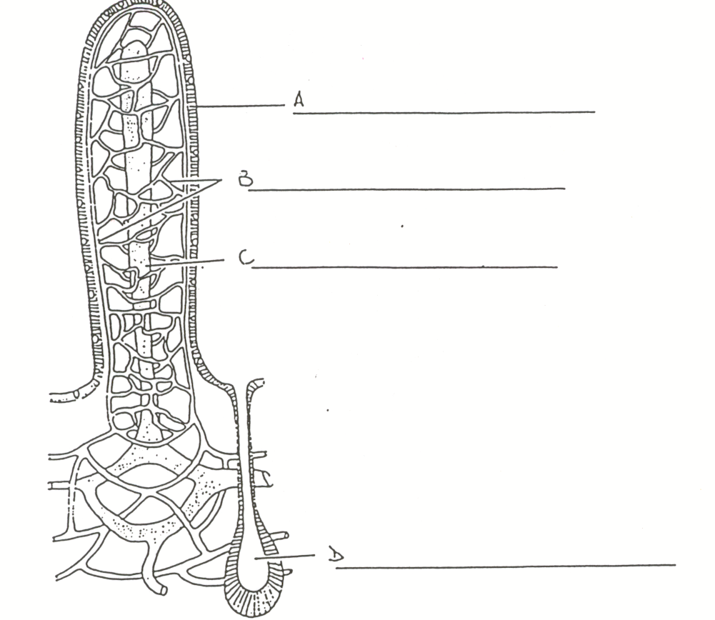

(2 marks)
45 g. Describe two ways a villus helps in the absorption of digested food.

- ___________________________________________________________
- ___________________________________________________________
(1 mark)
45 h. Name and describe the process used to move food through the alimentary canal.
___________________________________________________________
___________________________________________________________
(1 mark)

46 a. Describe the milk let down reflex.

___________________________________________________________
___________________________________________________________
(2 marks)
46 b. Give two reasons why breast feeding is better for a baby than bottle feeding.

i ___________________________________________________________
ii ___________________________________________________________
(1 mark)

Question 47 refers to the diagram below
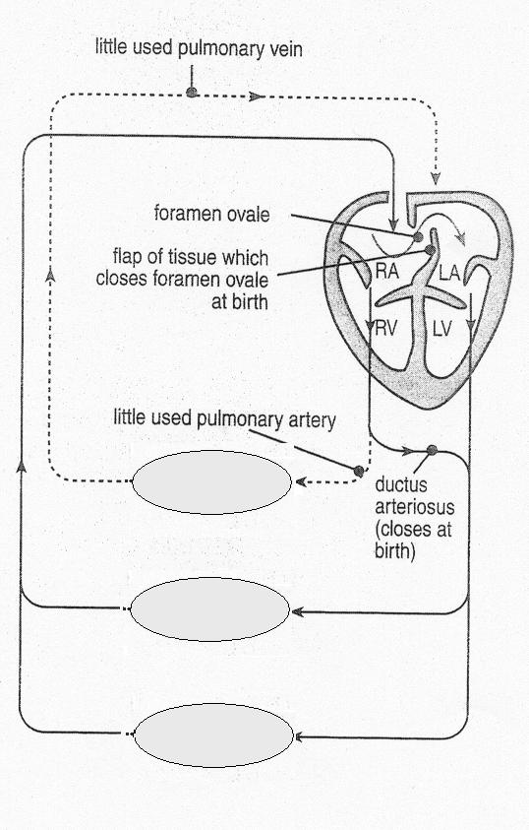

A
E

C
B

Other Tissues

D

47 a. Identify

A ___________________________________________________________
B ___________________________________________________________
C ___________________________________________________________
D ___________________________________________________________
(2 marks)
47 b. Why are A and B necessary in foetal circulation?

___________________________________________________________
___________________________________________________________
___________________________________________________________
___________________________________________________________
___________________________________________________________
___________________________________________________________
(2 marks)

47 c. What structural changes take place in the foetal heart at the time of birth?

___________________________________________________________
___________________________________________________________
___________________________________________________________
___________________________________________________________
___________________________________________________________
___________________________________________________________
(2 marks)

48 a. During the embryo stage of development the cells of the embryo differentiate into 3 primary tissue layers; the endoderm, mesoderm and ectoderm.

List 2 body tissues in the fully developed human body that originated from each primary tissue layer in the foetus.

ENDODERM (i) ____________________________________
(ii) ____________________________________
MESODERM (i) _____________________________________
(ii) _____________________________________
ECTODERM (i) _____________________________________
(ii) _____________________________________
(3 marks)

48 b. During which weeks of pregnancy is the embryo stage?

___________________________________________________________
(1/2 mark)

48 c. The embryological stage is the most crucial in terms of physical deformities in the developing embryo. What is the name given to those agents in the environment that can cause physical abnormalities?

___________________________________________________________
(1/2 mark)
48 d. Give 2 examples of these agents and describe two specific effects of each.

___________________________________________________________ ___________________________________________________________
___________________________________________________________
___________________________________________________________
___________________________________________________________
___________________________________________________________
___________________________________________________________
___________________________________________________________
(4 marks)
49 Complete the table below.

HORMONE | SITE OF PRODUCTION | ORGANS TARGETED | EFFECTS
FSH

LH

OESTROGEN

(6 marks)

Question 50 refers to the graph below which shows the development of speech in infants.

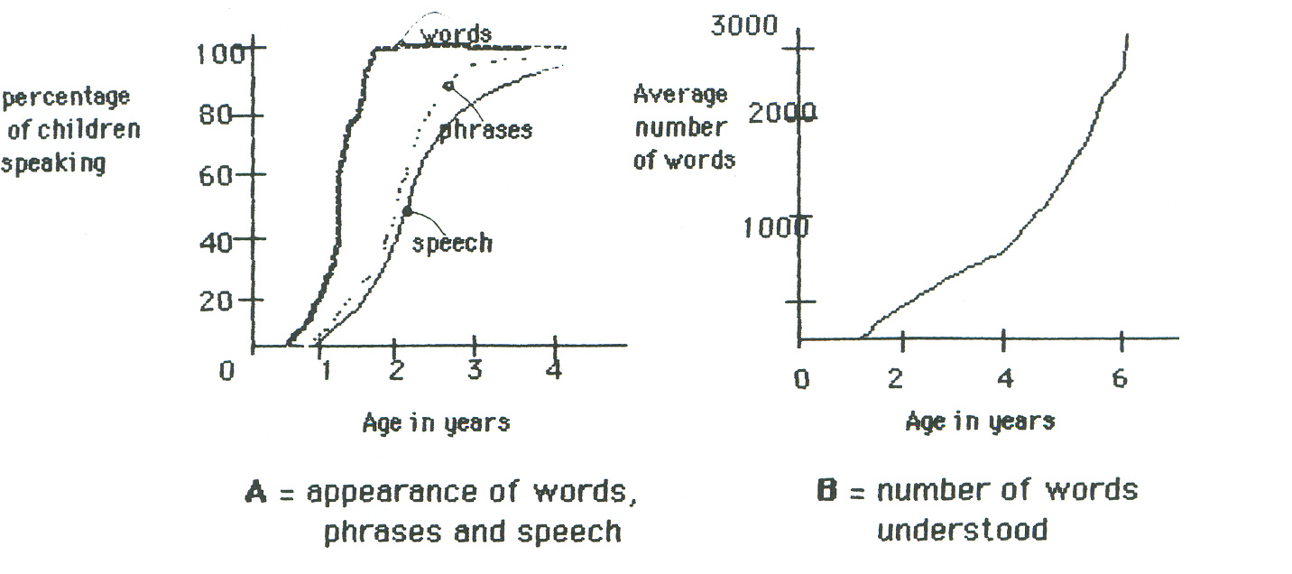

50a. Using ONLY graph A describe the difference in vocabulary of a child one year old compared to a child of two years old.

___________________________________________________________
___________________________________________________________
___________________________________________________________
(2 marks)
50b. The development of speech depends on the understanding of words. Before a child can use a word in a sentence, he or she must understand the meaning of the word. From graph B, give the increase in the number of words a child can understand as it grows from 2 to 6 years of age.

___________________________________________________________
___________________________________________________________
___________________________________________________________
(2 marks)
50c. When a baby can control it’s movements, it develops gross movements before fine movements. Using the hand as an example, describe one gross movement and one fine movement.

___________________________________________________________
___________________________________________________________
___________________________________________________________
(2 marks)
51. A sample of gastric juice was split into four portions. Each portion was incubated at 37O with 10 grams of gelatin (a pure protein) but the acidity (or ph) of each was varied as follows:

Portion A | pH 2 (very acidic) | Portion B | pH 5 (slightly acid)
Portion C | pH 7 (neutral) | Portions D | pH 9 (alkaline)

The time taken for the gastric juice to break down the gelatin was measured at each pH level. In this experiment what was:
a) the independent variable?____________________________________ (1 mark)
b) the dependent variable? _____________________________________
(1 mark)
c) Give 2 controlled variables in the experiment

______________________________________________________________________________________________________________________________
(1 mark)
d) Suggest one way in which you could increase your confidence in the results obtained in the experiment.

(1 mark)
e) At which pH would you expect the activity of the gastric juice to be highest? (ie. Shortest time to break down the gelatin). Explain why.

____________________________________________________________________________________________________________________________________________________________________________________________________________________________________________________________ (2 marks)


HUMAN BIOLOGY

NAME : _______________________________

Please indicate your answer with a cross (X) within the box.

1 | A | B | C | D | E |  | 21 | A | B | C | D | E
2 | A | B | C | D | E |  | 22 | A | B | C | D | E
3 | A | B | C | D | E |  | 23 | A | B | C | D | E
4 | A | B | C | D | E |  | 24 | A | B | C | D | E
5 | A | B | C | D | E |  | 25 | A | B | C | D | E
6 | A | B | C | D | E |  | 26 | A | B | C | D | E
7 | A | B | C | D | E |  | 27 | A | B | C | D | E
8 | A | B | C | D | E |  | 28 | A | B | C | D | E
9 | A | B | C | D | E |  | 29 | A | B | C | D | E
10 | A | B | C | D | E |  | 30 | A | B | C | D | E
11 | A | B | C | D | E |  | 31 | A | B | C | D | E
12 | A | B | C | D | E |  | 32 | A | B | C | D | E
13 | A | B | C | D | E |  | 33 | A | B | C | D | E
14 | A | B | C | D | E |  | 34 | A | B | C | D | E
15 | A | B | C | D | E |  | 35 | A | B | C | D | E
16 | A | B | C | D | E |  | 36 | A | B | C | D | E
17 | A | B | C | D | E |  | 37 | A | B | C | D | E
18 | A | B | C | D | E |  | 38 | A | B | C | D | E
19 | A | B | C | D | E |  | 39 | A | B | C | D | E
20 | A | B | C | D | E |  | 40 | A | B | C | D | E

Name: TEACHER:

YEAR 11 SEMESTER TWO 2004

HUMAN BIOLOGY EXAMINATION

Part 3: EXTENDED ANSWERS

Answer question 1 or question 2

AND

Answer question 3 or question 4.

- Fill in the answers to your essays in this booklet.
- Number your questions appropriately.
- All answers are to be written in blue or black biro pen.
- Diagrams are to be done in pencil with labels.
- Spelling and grammar count towards your final mark.
- Good luck!!

Part 3 – EXTENDED ANSWER – 40 MARKS.

Marks will be deducted for spelling and poorly structured answers.
Illustrate your answers with diagrams, where appropriate.

Question 1
The biological effects of senescence on the human body are widespread.
(a) What is senescence? (2)
(b) Discuss the changes which occur in five of the body’s systems. (15)
(c) Discuss the social and psychological problems with which the aged in our society must cope. (3)
(20 marks)

OR

Question 2
Outline five different methods of birth control which are available.
Discuss in your answer
(a) The mechanisms by which each method works or is thought to work. (7)
(b) The effectiveness of each of these methods. (5)
(c) The side effects of each these methods. (5)
(d) Cultural factors preventing the widespread use of certain methods in some countries. (3)
(20 marks)

AND

PART 3 CONTINUED.

Marks will be deducted for spelling and poorly structured answers.
Illustrate your answers with diagrams, where appropriate.

Question 3

You decide to buy a cheese sandwich to eat for lunch from the school canteen.
(a) Describe the digestive processes that occur on the protein in the cheese sandwich. (15)
(b) After the sandwich, you sit back and contemplate whether you made the best choice from the school menu. What other nutrients should you have included in your lunch and what foods from the canteen would contain these nutrients to supplement your cheese sandwich? (5)
(20 marks)

OR

Question 4

After fertilization occurs, changes develop in the mother’s body.
(a) Describe the structure of the uterus during pregnancy and explain its function.(6)
(b) Explain the role hormones play in developing the uterus for pregnancy. (5)
(c) What more obvious changes would a woman notice if she was pregnant? (4)
(d) Pregnancy finishes with the process of childbirth. Describe what happens during the three stages of labour. Describe the role of hormones during childbirth. (5)
(20 marks)

